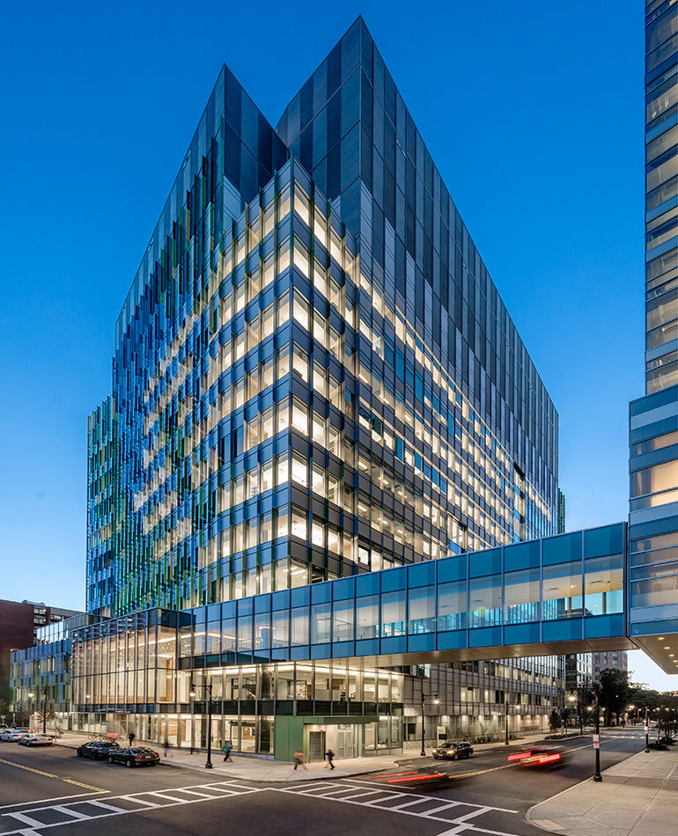
2026 Introductory Course for Allergy and Immunology Fellows
JULY 6 - 10, 2026
SIMMONS UNIVERSITY
300 THE FENWAY
BOSTON, MA 02115

Course Directors:
MARIANA CASTELLS, M.D., Ph.D.
PATRICK BRENNAN, M.D., Ph.D.
AYOBAMI AKENROYE, M.B.Ch.B., M.P.H., Ph.D.

Coordinator: Amelia Maloney

Monday, July 6, 2026
Time | Session Title | Faculty | Institution
8:00am -  8:15am | BREAKFAST
8:15am -  8:25am | Welcome / Introduction | Mariana Castells, M.D., Ph.D., Patrick Brennan, M.D., Ph.D., Ayobami Akenroye, M.B.Ch.B., M.P.H., Ph.D. | BWH
8:25am -  8:50am | Origins of Immunity | Duane Wesemann, M.D., Ph.D. | BWH
8:55am -  9:30am | B Cells and Immunoglobulin Production | Sarita Patil, M.D. | MGH
9:35am -  10:10am | T cells and Innate Lymphoid Cells | Patrick Brennan, M.D., Ph.D. | BWH
10:15am -  10:30am | COFFEE BREAK / EXHIBIT BOOTH TIME
10:35am -  11:10am | Neutrophils | Peter Nigrovic, M.D. | BCH
11:15am -  11:50am | Mast Cell Biology | Dan Dwyer, Ph.D. | BWH
11:55am -  12:30pm | The Microbiome and Metabolome in Allergic Disease | Rachel Kelly, Ph.D. | BWH
12:35pm -  1:15pm | LUNCH / EXHIBIT BOOTH TIME
1:15pm -  1:50pm | Neuroimmunology | Caroline Sokol, M.D., Ph.D. | MGH
1:55pm -  2:35pm | The Epithelium in Allergic Disease | Lora Bankova, M.D. | BWH
2:40pm -  3:30pm | Ice Cream Social

Tuesday, July 7, 2026

Time | Session Title | Faculty | Institution
8:00am -  8:15am | BREAKFAST
8:15am -  8:50am | Primary Immunodeficiencies - T Cells | Craig Platt, M.D., Ph.D. | BCH
8:55am -  9:30am | Primary Immunodeficiencies - B Cells | Carolyn Baloh, M.D. | BWH
9:35am -  10:10am | CVID and Autoimmunity in PID | Jocelyn Farmer M.D., Ph.D. | LHMC
10:15am -  10:30am | COFFEE BREAK / EXHIBIT BOOTH TIME
10:35am -  11:10am | Urticaria | Karen Hsu-Blatman, M.D. | DHMC
11:15am -  11:50am | Medication Therapy of Asthma and Allergic Diseases | Camellia Hernandez, M.D. | BWH
11:55am -  12:30pm | Comorbidities and Asthma | Dinah Foer, M.D. | BWH
12:35pm -  1:15pm | LUNCH / EXHIBIT BOOTH TIME
1:15pm -  1:50pm | IgE and Immunoglobulin Sialylation | Michelle Conroy, M.D. | MGH
1:55pm -  2:30pm | Ocular Allergies | Stephen Anesi, M.D., F.A.C.S. | MERSI

Wednesday, July 8, 2026

Time | Session Title | Faculty | Institution
8:00am -  8:15am | BREAKFAST
8:15am -  8:50am | Eosinophilic GI Disorders | Wayne Shreffler, M.D., Ph.D. | MGH
8:55am -  9:30am | Pathobiology of Asthma | Nora Barrett, M.D. | BWH
9:35am -  10:10am | Diagnosis and Management of Asthma in Children | Bernard Kinane, M.D. | MGH
10:15am -  10:30am | COFFEE BREAK / EXHIBIT BOOTH TIME
10:35am -  11:10am | Biologics for Asthma | Ayobami Akenroye, M.B.Ch.B., M.P.H., Ph.D. | BWH
11:15am -  11:50am | Aspirin Exacerbated Respiratory Disease | Kathleen Buchheit, M.D. | BWH
11:55am -  12:30pm | Lung Physiology, PFTs, and Cases | Rebecca Sternschein, M.D. | BWH
12:35pm -  1:15pm | LUNCH / EXHIBIT BOOTH TIME
1:15pm -  1:50pm | Drug Allergy Across the Care Continuum | John Accarino, M.D. | MGH
1:55pm -  2:30pm | Rhinitis and Sinusitis | Rachel Roditi, M.D. | BWH

Time | Session Title | Faculty | Institution
8:00am -  8:15am | BREAKFAST
8:15am -  8:50am | Autoinflammatory Diseases | Pui Y. Lee, M.D., Ph.D. | BCH
8:55am -  9:30am | In Vivo and In Vitro Testing for Hypersensitivity | Morris Ling, M.D. | MGH
9:35am -  10:10am | Eosinophilia | Lourdes Ramirez, M.D., M.S. | BWH
10:15am -  10:30am | COFFEE BREAK / EXHIBIT BOOTH TIME
10:35am -  11:10am | Immunotherapy | David Hong, M.D. | BWH
11:15am -  11:50am | Angioedema | Aleena Banerji, M.D. | MGH
11:55am -  12:30pm | Mastocytosis and MCAS | Matthew Giannetti, M.D. | BWH
12:35pm -  1:15pm | LUNCH / EXHIBIT BOOTH TIME
1:15pm -  1:50pm | Atopic Dermatitis | Tina Ho, M.D., Ph.D. | BCH
1:55pm -  2:30pm | Contact Dermatitis and Patch Testing | Ari Goldminz, M.D. | BWH

Time | Session Title | Faculty | Institution
8:00am -  8:50am | NETWORKING BREAKFAST
8:55am -  9:30am | Practical Approach to Drug Allergy Consults | Anna Wolfson, M.D. | MGH
9:35am -  10:10am | Desensitizations for Drug HSR | Mariana Castells, M.D., Ph.D. | BWH
10:15am -  10:30am | COFFEE BREAK / EXHIBIT BOOTH TIME
10:35am -  11:10am | Food Allergy | Joyce Hsu, M.D. | BWH
11:15am -  11:50am | Psychological and Cognitive Impact of Mastocytosis, a paradigm of the brain impact in allergic diseases | Jennifer Nicoloro Santa Barbara, Ph.D. | BWH
11:55am -  12:30pm | Anaphylaxis | Rebecca Saff, M.D., Ph.D. | MGH
12:35pm -  1:00pm | LUNCH / EXHIBIT BOOTH TIME
1:00pm -  2:00pm | Career Panel | Patrick Brennan, M.D., Ph.D.,  Dinah Foer M.D.,  Matthew Giannetti, M.D.,  Lakiea Wright-Bello, M.D., M.A.T, M.P.H. | BWH

